INTELLIGENT VECHILE DAMAGE ASSESSMENT & COST ESTIMATOR FOR INSURANCE COMPANIES

Abstraction :
With the increasing number of fraudulent claims in the insurance industry, this issue needs to be contained. Car insurance fraud is the most common compared to all other types of fraudulent claims. Therefore, it is necessary to have a system to detect and prevent such fraud, and it is necessary to build a system to detect insurance fraud .This application we created can be used by car insurers to evaluate customer claims more quickly than other traditional methods that involve manual tasks. Therefore, this application helps find out if the claim is genuine or fraud while the customer is claiming insurance. It is more accurate and free of fraud than traditional methods.

Novelty :
The Car Damage Recognition system is a set of ML algorithms with an API that utilizes computer vision. Based on deep learning, the algorithms automatically detect a vehicle's body and analyze the extent of the damage. Paralleled machine learning and analytical pipelines speed the analysis process up to seconds to
- Recognise a car,
- Identify the car elements,
- Estimate preliminary damage of car elements and cost.

30 seconds for claim submission. Machine learning allows for recognizing damaged vehicle parts, accessing damage, making predictions about what kind of repair is needed, and estimating how much it may cost.

Feasibilty Of Ideas :
Car Damage Assessment is a set of tools and processes which allows companies to provide users with automatic analysis of car damage. Its important because it allows getting damage reports and repair cost estimation in minutes without waiting for an inspector.
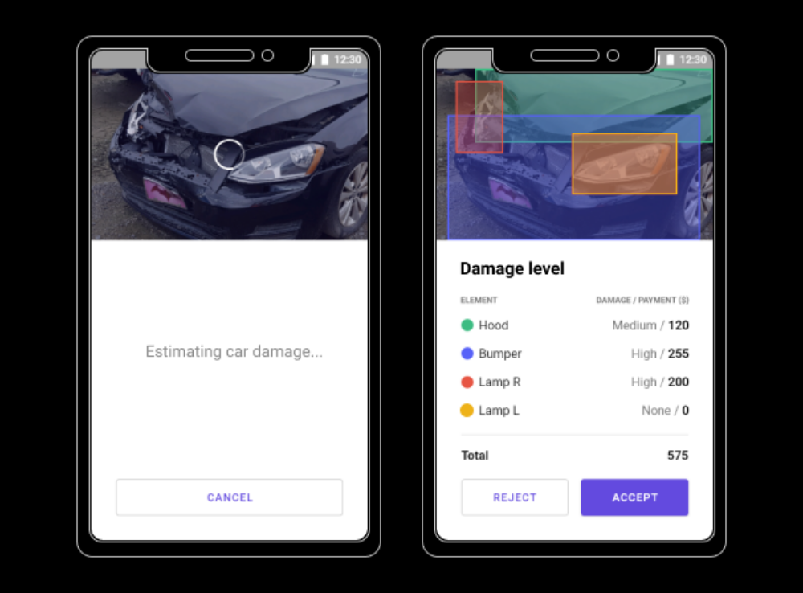

Vehicle damage detection has become possible thanks to proper training data and the installation of the necessary machine learning algorithms. The processing of each insurance claim presupposes the following steps:
- Process users image of the damaged vehicle
- Analyze car model
- Analyze car angle
- Locate damaged car parts
- Analyze component damage severity
- Prepare report

CAR-DAMAGE-DETECTION ALGORITHM FRAMEWORK :
The vehicle-damage-detection and segmentation system based on the Mask RCNN model designed in this paper. It can be seen from the figure that an image of the damaged part of the car is selected and collected according to the demand, and the data are marked by the LabelMe annotation tool to make a dataset in the.json format, which is divided into a training set and a test set. The data are sent to the Mask RCNN for feature extraction and classification prediction and segmentation masking, and the car-damage-detection result is output.

Business Model :
The solution speeds up data processing, saving the companys spendings on human resources, defending form fraud (in 80% and more), and boosting the process of image data analysis in times. The system is used on sight and guides a user on actions to meet photo requirements. Deploying Car Damage Recognition, businesses replace a human-operated time-consuming process of claims proceeding and approval with machine learning algorithms and analytical systems.
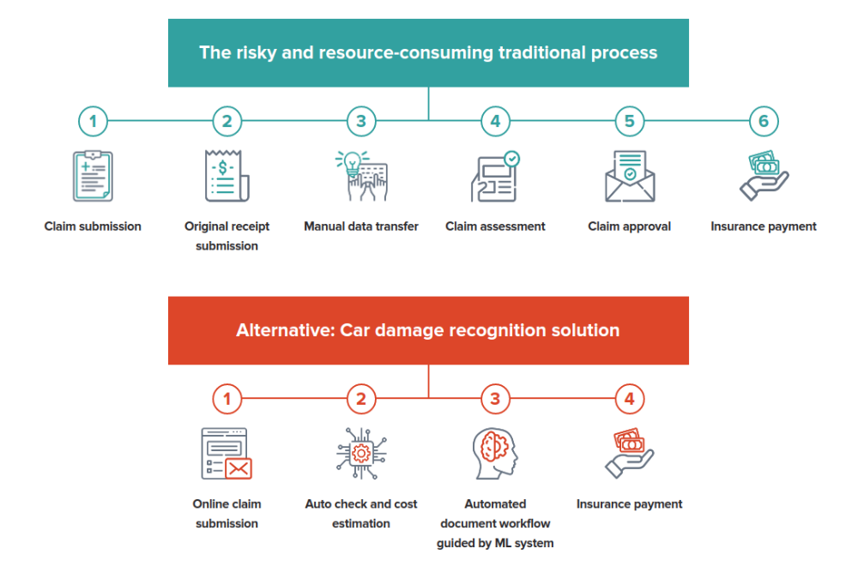
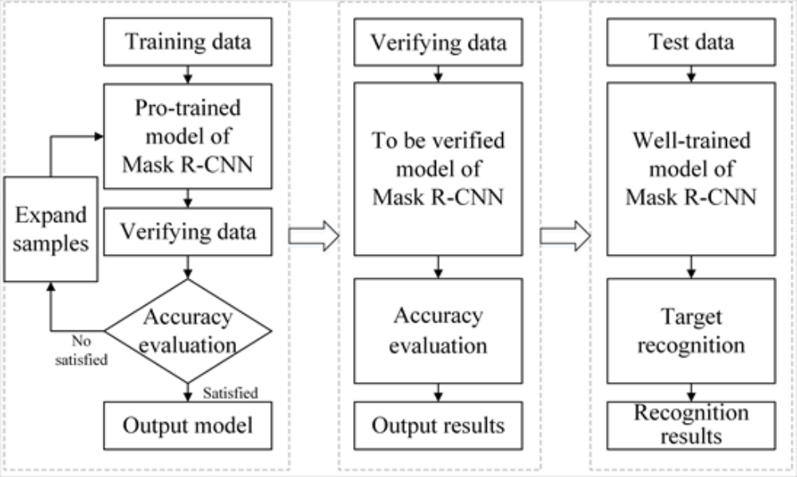

Scalability :
Provides an automated framework using advanced techniques and algorithms to scale the process of claim settlements. Benefits Insurance companies, car rental services and car repair services to quickly provide cost fixes for the damages the system analyzes.
They need to be able to quickly assess and analyze data from various sources and provide exact estimations. It also requires analysis and estimation of health damage, medical services, etc. inaccurate and delayed estimates will spoil the relations with customers and the companys reputation. Machine learning enhanced solutions help in monitoring drivers behavior, thus you pay the way you drive.

